Day 23 Agenda

You will be having a Quiz in between 3 p.m to 6p.m (Week 5 topics & Week 6 topics)

Spring AOP , Spring Data JPA, Spring Web MVC

Spring is a popular Java based Framework to create loosely coupled Java Applications.

Spring is also called as Framework of Frameworks. (It supports various other frameworks also)

Spring uses 2 important design patterns namely IoC (Inversion of Control) & DI (Dependency Injection)

Spring framework contains many modules

1. Spring Core – IoC Container, DI
2. Spring Data – Deals with Database (Simplifies the process of interaction with Database)
3. Spring Web – Helps to create Spring based web Applications (Restful Web Services)
4. Spring Security – Helps to add security feature to the Spring based applications
5. Spring AOP (Aspect Oriented Programming)

Lombok Is a small tool which will automatically generate the boiler plate codes

The official site for Lombok is <https://projectlombok.org>

Download Lombok jar from official site, double click to install it to the IDE

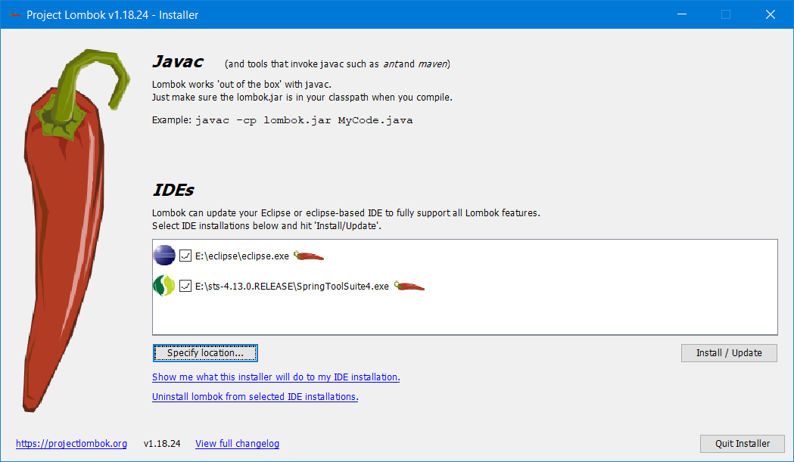

This will automatically search for the available IDE and click on the Install/update button.

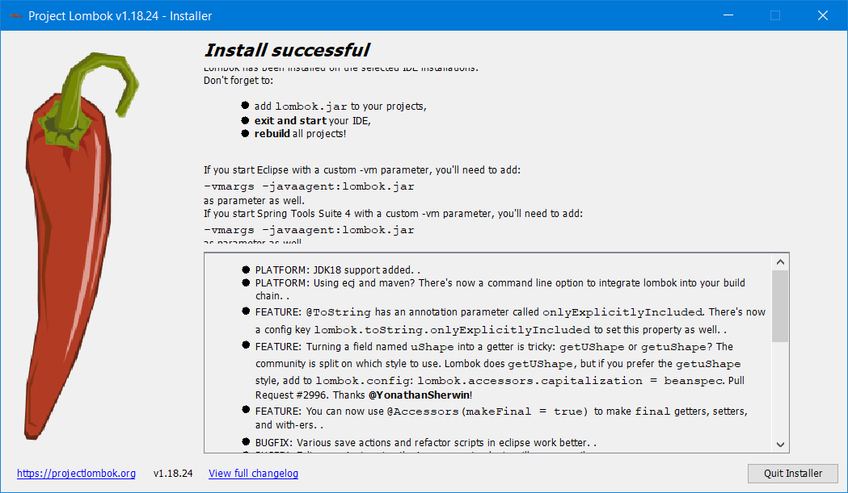

Lombok Annotations

1. @Data (Class-level annotations)
2. @NoArgsConstructor (-do-)
3. @AllArgsConstructor
4. @EqualsAndHashcode
5. @ToString (-do-)
6. @Getter (property level annotation)
7. @Setter (-do-)

Normally to create object, we use “new” keyword along with the constructor. This will lead to tight-coupled code.

We use Spring Framework, and which uses dependency injection. This helps to create loosely coupled java applications.

Objects will be created using XML configuration file. (These objects which is created by xml files are called as beans in spring framework)

Scope of Bean – Specifying the accessibility of a bean is called as scope of bean.

6 types of Bean Scope

1. Singleton (Default) Only one instance can be created
2. Prototype
3. SessionScope (Valid only for web-aware application-context)
4. RequestScope (-do-)
5. GlobalSessionScope (-do-)
6. ApplicationScope (-do-)

XML:

<!-- The following is redundant since the singleton scope is the implicit behavior -->

<bean id="exampleBean" class="com.revature.example.ExampleBean" scope="singleton"/>

<bean id="protoBean" class="com.revature.example.ProtoBean" scope="prototype"/>

<!-- etc... -->

Annotation:

@Configuration

public class AppConfig {

@Bean

@Scope("singleton") // This is not required since this is implicit behavior

public ExampleBean exampleBean() {

// ...

}

@Bean

@Scope("prototype")

public ProtoBean protoBean() {

// ...

}

// etc...

}

Spring framework heavily depends upon many annotations

1. @Controller (This will allow us to create a Controller POJO class – Which will contains the Web Service end points)
2. @Bean
3. @Repository
4. @Service
5. @Component

Spring Framework the FrontController is nothing but DispatcherServlet

@Annotations will help to remove xml configurations.

<https://www.javatpoint.com/steps-to-create-spring-application>

Spring MVC is helping to create Web Based Applications using Spring framework.

Spring MVC annotations (Model – View – Controller )

Model represents the Data (Usually the Database Tables)

View represents User Interface (HTML response)

Controller represents the Back end code (Java/.Net/Python/Ruby…. )

Important Spring MVC Annotations

1. @Controller (Used to make a java class as a controller class)
2. @RequestMapping (It’s a generic annotation and it can be used for any type of http operation)
3. @GetMapping (used with http get method) – Read operation
4. @PostMapping (Used for http post method) – Write/Insert/ Add operation
5. @Deletemapping (Used for http delete method) – Delete operation
6. @PutMapping (used for http put method) – Update Operation
7. @PathVariable
8. @RequestParam
9. @RequestBody

<https://github.com/syskantechnosoft/Spring3MVCwithHibernate/blob/master/Spring3HibernateApp.war>

Download and open war file in Eclipse or STS

File 🡪 Import 🡪 war (select the .war file from the downloads folder)